Loading images of different sizes

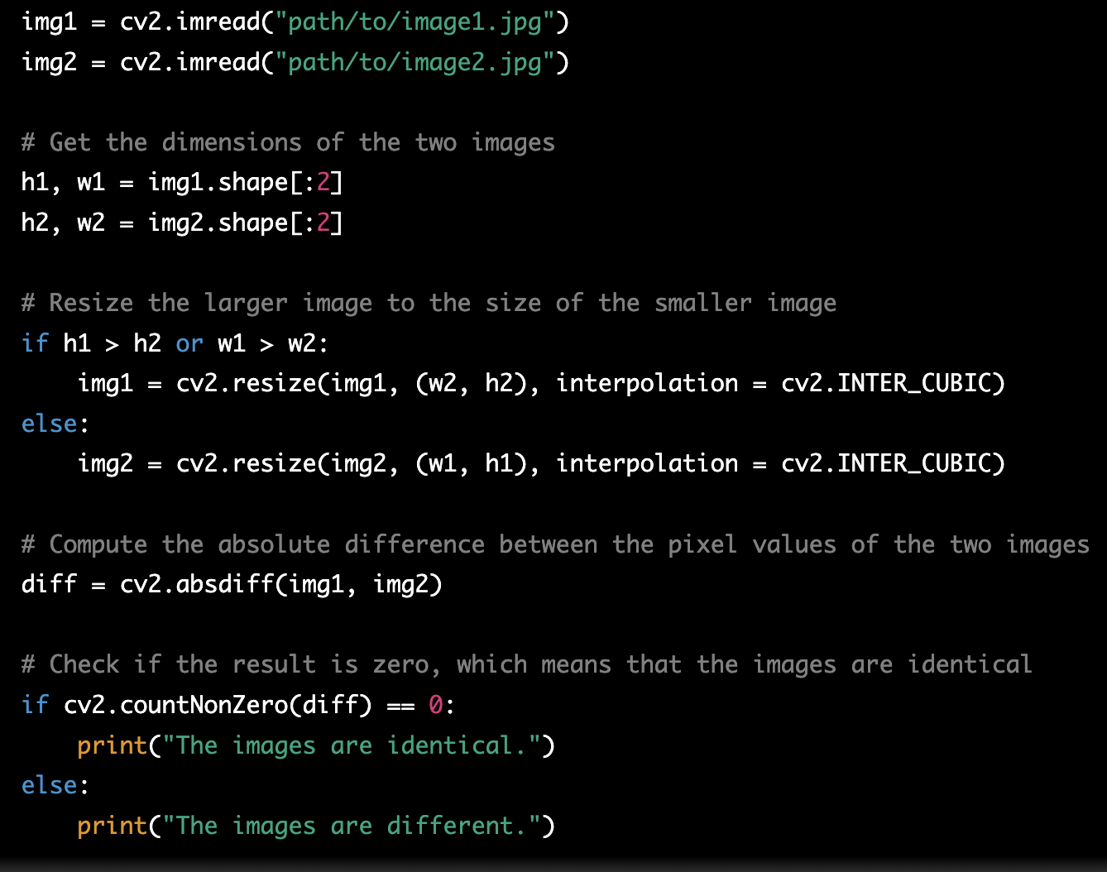

Difference beween 2 images

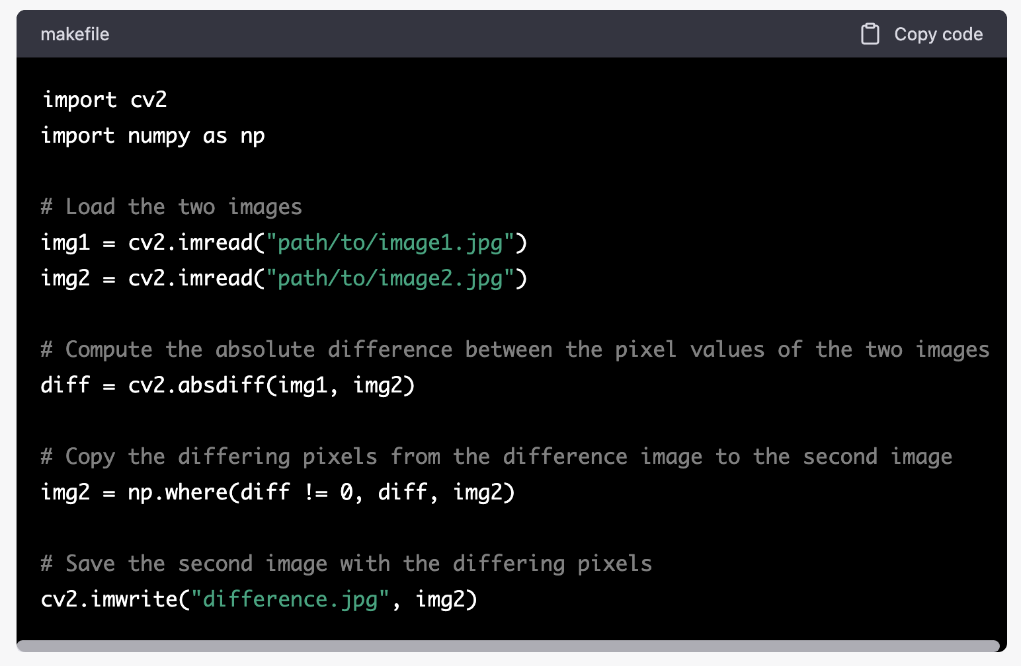

Manually modifying the pixel values

